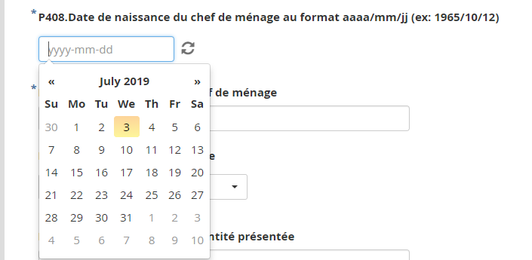

Chief household birth date to not allow age less than 15 years