Live Data from Our Central Server
TestProject-Blast
This is an R Notebook demonstrating the Live Data Analysis from Central Server.
$$ \\[0.1in] $$
Here is the code-block to fetch data from the Central Server and counts total sample size!
loadpkg <- function(toLoad){
for(lib in toLoad){
if(! lib %in% installed.packages()[,1]) {
# install.packages(lib, repos='http://cran.rstudio.com/')
}
suppressMessages( library(lib, character.only=TRUE) )
}
}
loadpkg(c("dplyr", "ReporteRs", "readxl", "rio" , "openxlsx", "ruODK", "gridExtra", "stringr", "ggplot2"))
source("http://bit.ly/theme_pub") ## Theme set for ggplot2
theme_set(theme_pub()) ## Theme set for ggplot2
# Set project to "TestProject-Blast"
project <- "https://central.pulsefe.org/v1/projects/17/forms/2225F110.svc"
interviewer_variable <- "int_details_interviewer_name"
# `ruODK` users only need default settings to their ODK Central:
ru_setup(url = "https://xxx.xxx.xxx",
un = "username",
pw = "password" ,
svc = project,
tz = "Asia/Calcutta")
# File attachment download location
loc <- fs::path("media")
Sys.sleep(5) ## 5 Sec wait
fq_data <- ruODK::odata_submission_get(
table = fq_svc$name[1],
local_dir = loc,
wkt=TRUE)
# Find total submissions
n <- as.numeric(unlist(count(fq_data)))
Total Sample Size: 109
Here is the code block that counts date-wise productivity and shows in a Table and Pie Chart
# Find productivity per day
datesvector <- as.Date(fq_data$todaydate, format="%Y/%m/%d")
dates <- as.Date(unique(fq_data$todaydate, format="%Y/%m/%d"))
l <- length(dates)
i <- 1
datewisecount <- data.frame()
while (i <= l) {
datewisecount_i <- data.frame()
datei <- dates[i]
datecount <- sum(datesvector == datei)
datewisecount_i <- data.frame(Date = datei, Count = datecount)
datewisecount <- rbind(datewisecount,datewisecount_i)
rm(datewisecount_i)
i <- i + 1
}
datewisecount$Percent <- datewisecount$Count*100 / sum(datewisecount$Count) ## Add percent
bar <- qplot(x= todaydate, data = fq_data) ## Create bar chart
bar <- bar + labs(colour = "Cylinders") + labs(title = "Productivity by Day") + labs(x = "dates")
tbl <- tableGrob(datewisecount) ## Create Table
grid.arrange(tbl, bar, nrow=1, newpage = FALSE) ## show table and bar in one row
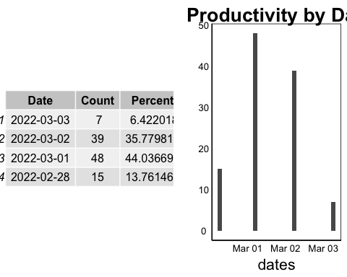
$$ \\[0.1in] $$
Productivity Per Device
The next code block finds productivity per device
# Find productivity per device ID
devicevector <- (paste0(str_to_title(str_trim(fq_data$int_details_interviewer_name)), "-" , fq_data$deviceid))
deviceunique <- unique(paste0(str_to_title(str_trim(fq_data$int_details_interviewer_name)),"-",fq_data$deviceid))
l <- length(deviceunique)
i <- 1
devicewisecount <- data.frame()
while (i <= l) {
devicewisecount_i <- data.frame()
devicei <- deviceunique[i]
#interviewer <- filter(inter_df, deviceid == devicei)
devicecount <- sum(devicevector == devicei)
device <- unlist(strsplit(devicei,"-"))
devicewisecount_i <- data.frame(Name = device[1], DeviceID = device[2], Count = devicecount)
devicewisecount <- rbind(devicewisecount,devicewisecount_i)
rm(devicewisecount_i)
i <- i + 1
}
devicewisecount <- devicewisecount[order(devicewisecount$Name),]
tbl_device <- tableGrob(devicewisecount, rows=NULL) ## Create Table
grid.arrange(tbl_device, nrow=1, newpage = TRUE) ## show table and bar in one row
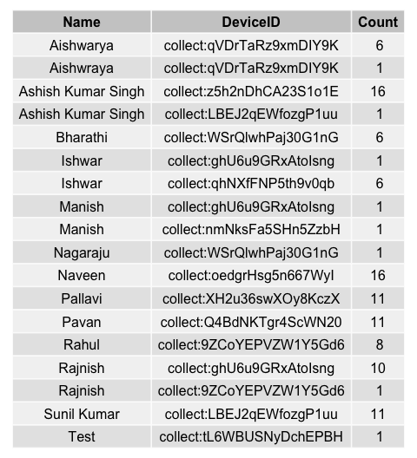
$$ \\[0.1in] $$
Analysis
source("/Users/debjitbiswas/shiny-projectstatus/crosstab.r") ## Load crosstab function from "http://pcwww.liv.ac.uk/~william/R/crosstab.r"
Frequency & Percentage by Selected Center (d_selected_centre)
crosstab(fq_data, row.vars = "d_selected_centre", type = "f")
## d_selected_centre Count
## 1 57
## 2 52
## Sum 109
crosstab(fq_data, row.vars = "d_selected_centre", type = "r")
## d_selected_centre %
## 1 52.29
## 2 47.71
## Sum 100.00
Frequency by data Point Q1 (d_q1) & Q3 (d_q3)
crosstab(fq_data, row.vars = "d_q1", type = "f")
## d_q1 Count
## 1 8
## 10 2
## 2 30
## 3 11
## 4 10
## 5 5
## 7 1
## 8 27
## 9 15
## Sum 109
crosstab(fq_data, row.vars = "d_q3", type = "f")
## d_q3 Count
## 1 50
## 2 12
## 3 1
## 4 35
## 5 10
## 6 1
## Sum 109
Crosstab Selected Center with data Point Q3 (d_q3)
crosstab(fq_data, row.vars = "d_selected_centre", col.vars = "d_q3", type = "f")
## d_q3 1 2 3 4 5 6 Sum
## d_selected_centre
## 1 34 1 1 18 2 1 57
## 2 16 11 0 17 8 0 52
## Sum 50 12 1 35 10 1 109
Statistical Summary of a Numeric Field
summary(as.numeric(fq_data$d_q13_x_1))
## Min. 1st Qu. Median Mean 3rd Qu. Max.
## 80000 100000 110000 112028 120000 200000
table(as.numeric(fq_data$d_q13_x_1))
##
## 80000 85000 90000 90100 92000 95000 1e+05 105000 109000 110000 115000
## 4 5 9 1 1 6 24 1 1 17 4
## 120000 125000 130000 135000 150000 2e+05
## 15 4 3 2 8 4
plot(table(as.numeric(fq_data$d_q13_x_1)))
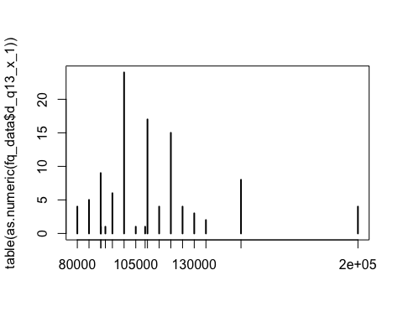
hist.default(as.numeric(fq_data$d_q13_x_1),col='gray')
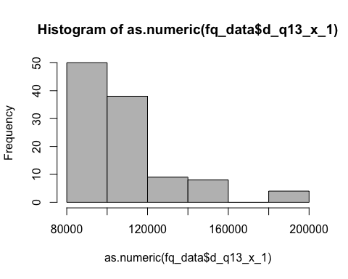
Bivariate statistical analysis | Scatter Plot X = d_q14a_r1 ~ Y = d_q13_x_1
plot(as.numeric(fq_data$d_q13_x_1)~fq_data$d_q14a_r1,col='blue')
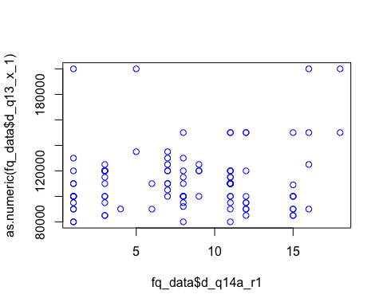
T Test
t.test(as.numeric(fq_data$d_q14a_r1))
##
## One Sample t-test
##
## data: as.numeric(fq_data$d_q14a_r1)
## t = 17.189, df = 108, p-value < 2.2e-16
## alternative hypothesis: true mean is not equal to 0
## 95 percent confidence interval:
## 7.077457 8.922543
## sample estimates:
## mean of x
## 8

