XLSFORM Code where two text data type vafriable referenced by $ sign preceding variable name in braces (${P401} for first name and ${P402} for family name) are spaced with keyboard space bar
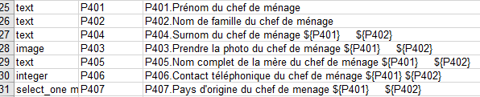

Display of two Text type data spaced on online form (via Enketo Express for Kobotoolbox) : the two text data type variables (${P401} for first name and ${P402} for family name) contain are still together but need to be separated as normal way
